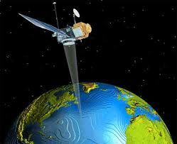
Benha University
Faculty of Engineering _Shoubra
Surveying Engineering Department
Fourth Year
Year: 2017/2018
Semester: One
Remote Sensing and Photo Interpretation
Assignment No: 2

Pixel, Images and Colors

- What is an Image and Pyramid Layers?
- Types of Image Resolution.
- Define the following terms:
- Digital Number (DN).
- Ground Sample Distance (GSD).
- IFOV.
- Color composite images.
- False color composite.
- Natural color composite.
- Explain how a digital image could be represented in a digital computer.
- Write in detail about the following:
- Applications of remote sensing.
- Current Specifications of Satellites.

